A Digital Clock Using LabVIEW

Jeffrey Bach
UNM PURSUE Program

LabVIEW is an icon-based software allowing control of processes and instrumentation, and creation of virtual instruments (VI’s) on the PC. The LabVIEW programming language is generally easier to write and understand than traditional text-based programming languages.

This project uses the capabilities of LabVIEW to display the current time of the computer in a digital form on the computer screen. The program serves as a useful introduction to the capabilities of LabVIEW as a programming language.

The LabVIEW function, Get Date/Time In Seconds, gets the time from the computer and returns a value that represents the number of seconds that have passed since January 1, 1904. This function is illustrated below:

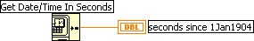

Figure 1 – LabVIEW function that returns the current time from the computer.

The time will be indicated using Boolean indicators on the front panel. These indicators can be resized to look more like a 7-segment digital display. These indicators should be contained in a cluster to make the diagram appear cleaner. Figure 2 shows Boolean indicators, and Figure 3 shows their representation as a cluster.

Figure 2 – Front Panel for Boolean cluster demonstration

Using clusters greatly simplifies the wiring on the block diagram, since only one wire needs to be passed from region (or function) to region (or function).
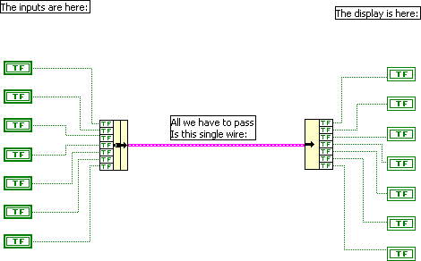

Figure 3 – Diagram for Boolean Cluster demonstration

Your program should contain a method of setting an alarm time, and then at the specified time the program should play a .WAV file on the sound card.

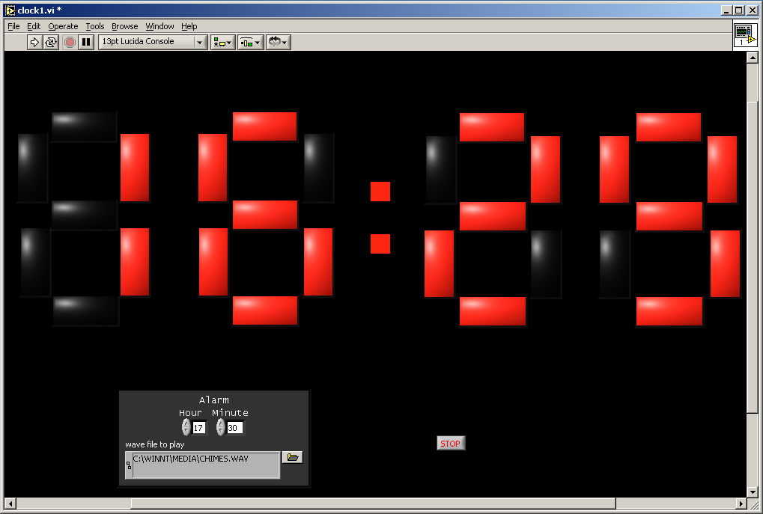A sample program has been written that demonstrates the required concepts. Your program must contain similar features. The sample program is shown below:

